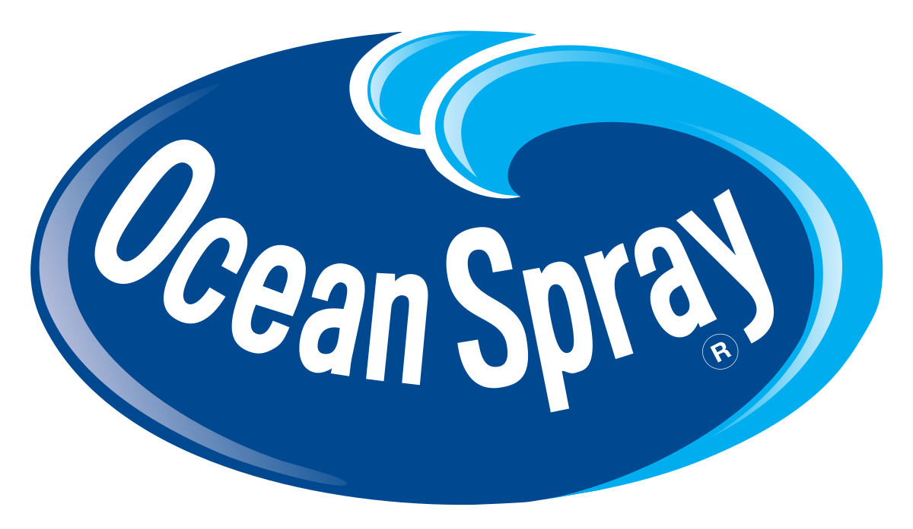

**Media Plan**

*Kiana Bailey, Olyvea Davis, Abrahan Garcia, Alex Gutierrez-Spencer, Kelsey Knapp, Jill Puckett*

**Executive Summary**

**Table of Contents**

**Executive Summary 1**

**Situation Analysis 2**

**Media Plan Flowchart 8**

**Media Objectives, Rationales,**

**and Strategies 9**

**Media Plan Evaluation 18**

**Appendix 19**

Ocean Spray Cranberry is one of the oldest cranberry brands in the United States. The co-op has grown from producing cranberry sauces and cranberry juice cocktail into a leading cranberry product-producer. Ocean Spray offers a growing number of cranberry products but is primarily recognized for their cranberry juice blends.

Although Ocean Spray is a leader in the cranberry industry, it falls short against competitors when it comes to juice sales among millennial consumers (beginning at ages 24-25). Through research and thoughtful planning, our team has come up with a media plan to entice young consumers to try and buy Ocean Spray juices. Crucial to Ocean Spray’s continued dominance in the cranberry and juice markets are a new crop of consumers: Millennials ages 24-35. Now established and entering the workforce, this group has the money to spend on name brand products and the time to learn about where their product is coming from and for what the brand stands.

Our media strategy will reach and engage with Millennials across the United States, creating meaning and brand loyalty that Ocean Spray has never before had with this audience. Focusing on 17 DMAs with high concentrations of millennial consumers, this campaign focuses on topics that Millennials care about and utilizes platforms that millennials are most likely to connect with, including social media and in-person, guerilla marketing street teams. By connecting with causes Millennials care about most, such as health and the environment, socially aware millennials will be likely to try, buy, and share the Ocean Spray Cranberry juice blend experience.

**Situation Analysis**

**Company and Industry Analysis**

Ocean Spray is a grower, producer and distributor of canned and bottled juices. The company is an agricultural cooperative owned by over 700 cranberry growers, supplying products to over 100 countries. Ocean Spray groups its offerings into five product categories: Juices and Drinks, Craisins Dried Cranberries, Sauces, Fresh Fruit, and Specialty Items. In December 2016, the company launched *Cranberry + Health*, a new juice drink intended for hospitals, managed-care facilities, and retirement homes.

In 2015, Mintel reported net sales equal to 960.1 million US dollars (USD) (Mintel, 2016). In 2016, it reported net sales of 955.5 million USD (Mintel, 2017). Juice in general has been experiencing stagnation, specifically 100% juice. Juice companies with highest market share are experiencing the largest declines. While private label brands saw a growth of 6.4%, smaller brands have continued to gain market share from the juice leaders (Mintel, 2017).

Other companies, like PepsiCo and Coca-Cola, have the ability to out-produce and provide a larger variety than Ocean Spray, creating a difficult environment in which to compete. While consumers are drinking less 100% juice, this is mainly due to the fact that orange juice sales are down (Mintel, 2017). This will allow Ocean Spray to step in and gain that market share by offering a product that’s taste cannot be duplicated. The goal for Ocean Spray in this media plan is to increase sales by creating brand recognition and consumption among adults ages 25-34. This campaign will utilize effective media to reach the target audience and showcase the value and flavor that come with the product.



**Situation Analysis (cont.)**

**Product/Brand Listening**

*BRAND & PRODUCT*Ocean Spray Cranberry Juice Cocktail has been on the market since 1931. The product and brand are both mature and widely known in the United States (US) market as a leading juice and snack product. To keep the brand interesting and relevant since the co-ops conception, Ocean Spray has expanded its product line with new products, such as juices with organic ingredients, little to no sugar, and energy drink options.

*SOCIAL* According to social media analysis, in most cases, Ocean Spray meets and exceeds consumer expectations for taste and quality of juice products. However, in regards to health, consumers on social media often express disappointment in high amounts of sugar per serving in Ocean Spray and other juice brand juices. Searching “Ocean Spray” on Social Mention gives a strength of 64%, a passion of 10%, a reach of 68%, and a sentiment of 4:1. The strength and reach of Ocean

*CAMPAIGNS*Currently,Ocean Spray describes the essence of its brand as “refreshing, unique, and vibrant.” The brand has been around for more than 85 years and has had many campaigns throughout its lifetime. These campaigns include but are not limited to: “The Growers Own Brand,” “Good for You,” and more recently, “Straight From the Bog.” Ocean Spray’s campaigns have each revolved around two

While the juice industry is widely criticized for the amount of sugar added to juice blends, Ocean Spray addresses this issue by offering several different juice products, including a “100% juice, no sugar added” option. Additionally, Ocean Spray caters to millennial interest in energy drinks, natural ingredients, and organic products with *Ocean Spray Cran-Energy*, *Ocean Spray Pure*, and *Ocean Spray Organic* juice drinks. (Ocean Spray, 2017)

Spray, at 64% and 68% respectively, indicate that the company is regularly discussed on social media by a fairly large audience. With a sentiment of 4:1, Ocean Spray receives four positive comments for every one negative comment. However, with a passion of only 10%, consumers are not consistently posting about Ocean Spray more than once, meaning loyalty may be low. (Social Mention, 2017)

two central themes: supporting local cranberry farmers and that cranberries and cranberry products are good for people. The most recent campaign, “Straight From the Bog,” focuses on both of these themes, as well as highlighting that many of Ocean Spray’s cranberry products are natural and therefore, more healthy (Ocean Spray, 2017).

**Situation Analysis (cont.)**

**Competitive Analysis**

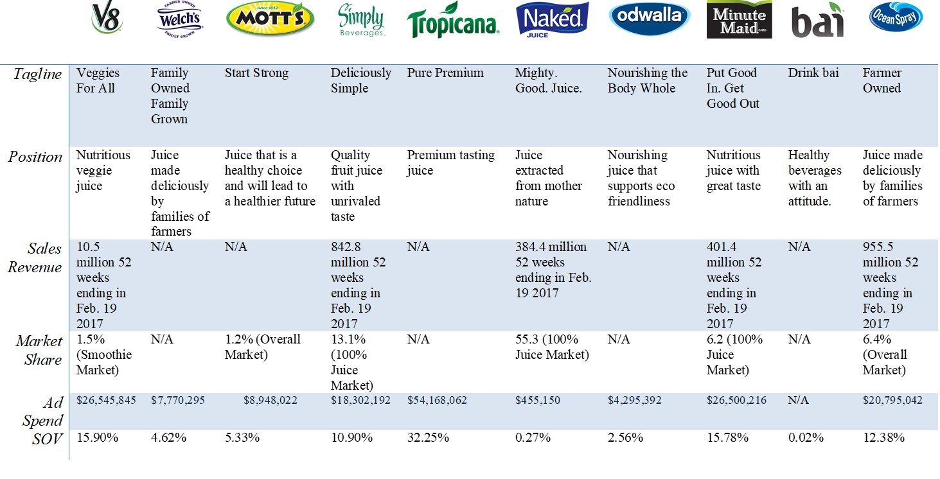

**Situation Analysis (cont.)**

**Geographic Market Analysis**

Ocean Spray is the main competitor in cranberry product sales, but in juice drink sales, its products are less popular. Not much juice consumption is shown outside of New England, some Southern states, and some Western states (US Food ScanTrack Markets, 2017). Cranberry juice is not a highly-consumed juice drink, so Ocean Spray must find an engaging way to connect with its intended audience more effectively. The highest-grossing juice-drink individuals are located in

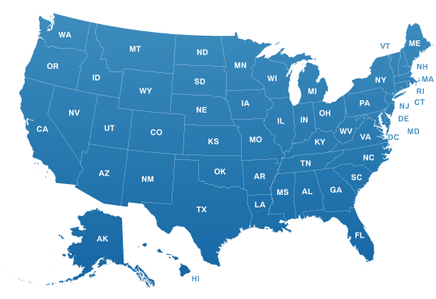

*Top 25 Millennial-Heavy Markets*

*Top 25 Juice Drink Markets*

areas such as Miami, Boston, Buffalo, and Baltimore (US Food ScanTrack Markets, 2017), but the areas with the highest increase and large amounts of millennials and, specifically, 25-34 year-olds, include cities such as Richmond, VA, Salt Lake City, Columbus, and Austin (Data USA, 2017). There are some areas that overlap, implying that a high population of 25-34 year-olds live in locations with high juice drink consumption.

**Situation Analysis (cont.)**

**Consumer Analysis**

As of February 2017, the current customers of Ocean Spray are predominantly young men and women. About 79% of men ages 18-34 have purchased a 100% juice drink within the last three months, along with women ages 18-34 at 81%. More specifically, of 18-34 year-olds, 63% of those men and 62% of those women have bought a 100% fruit juice drink. This may be because younger generations prefer sweeter tastes than those of older generations.

Those in rural areas believe juice is a staple breakfast drink more than those in large cities, small cities and towns, and suburban locations. Large cities are willing to pay more and focus on juices as a dieting technique about 7-9% more than those in the other areas.

Many consumers do not drink juice every day, but will drink it at least a couple times a month. This frequency may be because of the amount of sugar in juice drinks. Only 45% consider themselves heavy



juice drinkers, while 50% are moderate drinkers and 5% are infrequent. The percentage of heavy drinkers significantly declines among those with sugar concerns, dropping to 30%. Although sugar is a deterrent for consumers, 35% of juice drinkers still believe they are healthy and 48% believe it is a good substitution for soda.

Comparing parents ages 45 and older, younger parents consider juice a major drink in their household, as nine out of ten parents have bought 100% juice within the past three months. Likewise, parents who have more than one child are more likely to buy juice than those with only one child.

Other juice consumer beliefs are that it is a stable breakfast drink (35%), store brand is as good as name brand (28%), and juice cleanse diets are a healthy way to lose weight (16%).

(Bryant, 2017)

**Situation Analysis (cont.)**

**SWOT Analysis**

*STRENGTHS*

* Offers a variety of diet/light juice, 100% juice, and juice drinks
* Provides quality products that ensure food safety for consumers
* Known as a great brand of juice and like products to consumers across the country

*WEAKNESSES*

* Lacks diversity in terms of demographic reach by currently only seeking generations like baby boomers
* Has a low market share within the juice category compared to competitors

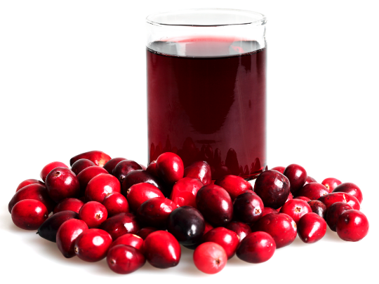

*OPPORTUNITIES*

* Expansion within the brand to more than current juice and dried fruit products
* Possible benefit from recent product launches produced in 2014
* Can gain eating-out trends within the market by pairing current products with related products at bars, restaurants, etc.

*THREATS*

* Has many competitors who offer cheaper prices for similar products
* Company’s rising labor cost in the US affects profitability

**Media Plan Flowchart**



**Media Objectives, Rationales, and Strategies**

**Target Audience**

*Objective:* This campaign’s purpose is to increase brand awareness and usage of Millennials ages 24-35 of Ocean Spray juice drinks by targeting specific areas in the United States.

Primary Demographic Profile

* Ages 24-35
* Population of 44 million

Secondary Demographic Profile

* Young women
* Women look to juice as a healthy drink alternative to soda more often than their male counterparts

Psychographic Profile

Millennials are completely different from previous generations. Although technology has been a major factor in their lives, these connected Millennials still enjoy cooking, travelling, and exercising. Their work ethic is different, as they are all about the relaxed work environment but still giving it their all. Millennials strive for approval in the workplace and are known for their punctuality. They believe in innovation, education, and transformation. They stand up for diversity, inclusion, and equality and are more confident now than ever. This group of unique individuals makes history with their explorative and original ideas.

*Rationale:* Millennials have become the most influential generation, and targeting this age group will create more opportunities for this brand. With health at the forefront, Ocean Spray juice will become an ideal drink for this young generation. It is important to increase loyalty among these young adults while they are deciding what juices to purchase.

**

**Media Objectives, Rationales, and Strategies (cont.)**

**Media Mix**

Ocean Spray is active on social media, but its content does not garner enough attention. The company’s content value will increase with an engaging social media presence. Media vehicles that attract the target market are social media and experiential advertising. The message will be simple; easy to understand and meaningful to the consumer.

**Internet** *($1,000,000)*

Ocean Spray Juice has an index number of 91 for consumption over the last 6 months among adults who are 25-34, according to University reporter (Spring 2016). It also has an index number of 153 for African Americans, 113 for Asian Americans, and 93 for Caucasian Americans. Banner ads will be run on CBSNews.com (Index 136), CheapTickets.com (Index 132), Fox.com (Index 127), MSN.com (Index 130), Nascar.com (Index 138), NBA.com (Index 143), NBCSports.com (Index 145), NBC.com (Index 137), and Overstock.com (Index 140). These banner ads will send the viewer to social media platforms offering special discounts for participating with the company’s hashtags (#). They will help drive 25-34 year olds to the platform by connecting with them on platforms that they already prefer. According to Small Business Trends, “Website visitors who are retargeted with ads are 70 percent more likely to convert on your website.” In one comScore study, retargeted ads lead to a 1,046 percent increase in branded search, a clear sign of heightened brand awareness and recall. (Small Business Trends, 2017)

**Out-Of-Home** *($1,000,000)*

We will utilize the out-of-home media in all 17 DMAs, first by sending out a street team to visit local Targets and other grocers to interact with guests while they’re in the juice aisle. In order to trend on social media, the street team will need eye-catching outfits to help define the movement. Digital billboards will be placed within five miles of the closest grocery store and used to help send the consumer to the nearest grocer. 55% of travelers who noticed a digital billboard in the past month were highly engaged, recalling the message shown most or every time they passed a digital board, according to Nielsen (2017).

**Social** *($1,000,000)*

According to University Reporter, consumers ages 25-34 scored an index of 141 for social media use within the last 30 days (2016). This creates the perfect opportunity to connect with the target market all day. Increasing brand awareness will be essential on social. Using sponsored ads periodically throughout the day will help utilize the social platforms, and creating a hashtag that allows users to share their Ocean Spray experience will be beneficial to increasing impressions.



**Media Objectives, Rationales, and Strategies (cont.)**

**Media Mix (cont.)**

“As of September, the mainly mobile photo sharing network had reached 800 million monthly active users, up from 600 million in December 2016. The app is one of themost popular social media networks worldwide.” (Statista, 2017) To utilize this platform, implementing sponsored ads that appear on the timeline of the target market will allow for increased brand recognition.

 “As of the third quarter of 2017, Facebook had 2.07 billion monthly active users. In the third quarter of 2012, the number of active Facebook users had surpassed 1 billion, making it the first social network ever to do so.” (Statista, 2017) With Facebook being the largest network for social, it is essential to create an active campaign that encourages users to interact with Ocean Spray content on Facebook.

 “62% of millennials say that if a brand engages with them on social networks, they are more likely to become a loyal customer. They expect brands to not only be on social networks, but to engage them.” (Forbes, 2015) Twitter’s platform is very different from other socials in the fact that brands often interact with users daily. Implementing a hashtag that encourages users to participate with the Ocean Spray brand will help drive awareness as well as sales.

**Streaming Radio** *($1,000,000)*

Radio is a great way to connect with the consumer just as they’re feeling thirsty or as the consumer is coming home from work at the end of the day, so advertising Ocean Spray across select radio stations and stations like Pandora will push the consumer towards the product. Every month, streaming radio has impressions on 32% of the population over the age of 12 (Edison 2017). Radio is also able to reach 92% of adults 18-34 every week (Nielsen 2017).

**Streaming Video**

Implementing YouTube 15-second pre-rolls that are not skippable will allow Ocean Spray to hit their target market, as more and more adults 25-34 years old are utilizing YouTube (Business Insider, 2015).

**Mobile** *($1,000,000)*

Almost 95% of all Americans have mobile phones, with 77% of those being smartphones (Pew Research Center, 2017). Considering a mobile phone hardly leaves an individual’s side, this is one of the best opportunities to connect with the consumer. Through an app, the consumer aged 25-34 can receive a coupon whenever they walk into a store that carries an Ocean Spray product, so even if the coupon is not used right then, it will create attention around the brand. A new rewards program would also help build the base for repeat customers, encouraging them to buy a variety of Ocean Spray products.

**Media Objectives, Rationales, and Strategies (cont.)**

**Reach and Frequency**

*Objective:*

*Rationale:* According to the Ostrow Frequency Model, Ocean Spray needs a minimum frequency of 3.2 because that is the lowest frequency that will be effective for media based on Ocean Spray factors. Also, according to REDBOOKS, ad spend among Ocean Spray’s competitors is mostly allocated in the first and second quarters. In order to align Ocean Spray with its competitors, it needs to dial up its reach and frequency in these quarters (REDBOOKS, 2016).



*Strategy:* Ocean Spray must optimize frequency because it is a mature, well-known brand but has many competitors. It has lower brand awareness than many of its competitors, as well as a lower market share. It currently has low involvement in the consumer purchase decision and low interest in its category of goods, but the low cost of its products is a competitive edge for Ocean Spray. There is strong to intense competition in the category, so these reach and frequency goals will take its purchase frequency above the current 2+ times per month.

**Media Objectives, Rationales, and Strategies (cont.)**

**Media Budget**

*Objective:* Media budget will be spent in geographic areas that have a high BDI index for Ocean Spray. 29.1% of the budget will be spent on Internet and social media, 31.1% will be spent on out-of-home, and 39.8% of the media budget will spent on streaming radio and streaming video.

*Rationale:* We are spending 29.1% of the media budget on internet and social media because almost 95% of all Americans have mobile phones, with 77% of those being smartphones (Pew Research Center, 2017). The 31.1% we are putting towards out-of-home includes a street team to visit local Target stores and other grocers to interact with guests while they’re in the juice aisle. In order to trend on social media, the street team will need eye-catching outfits to help define the movement. Digital billboards will also be included.

.

*Strategy:* Advertising through the various methods will be dependent upon sales per quarter. Each class has a percent of the budget that will be allocated towards it, as demonstrated below:

* Internet/Social/Mobile: 29.1%
* Out-Of-Home: 31.1%
* Streaming Radio/Video: 39.8%



**Media Objectives, Rationales, and Strategies (cont.)**

**Geography**

*Objective:*The media buys for Ocean Spray cranberry juice will be on a national scope, with a defensive, heavy-up spot schedule in the top 10 juice drink markets and light spot advertisements in the remaining top 11-17th juice drink markets, all of which correspond with the top millennial-heavy markets. These designated market areas (DMAs) include the 17 listed below:

1. Riverside-San Bernardino-Ontario, CA Metro Area
2. Jacksonville, FL
3. Miami-Fort Lauderdale-West Palm Beach, FL Metro Area
4. Tampa-St. Petersburg-Clearwater, FL Metro Area
5. Boston-Cambridge-Newton, MA-NH Metro Area
6. Baltimore-Columbia-Towson, MD Metro Area
7. Las Vegas-Henderson-Paradise, NV
8. Buffalo-Cheektowaga-Niagara Falls, NY Metro Area
9. Charlotte-Concord-Gastonia, NC-SC Metro Area
10. Raleigh, NC
11. Philadelphia-Camden-Wilmington, PA-NJ-DE-MD Metro Area
12. Pittsburgh, PA
13. Providence-Warwick, RI-MA Metro Area
14. Washington-Arlington-Alexandria, DC-VA-MD-WV Metro Area
15. Richmond, VA
16. Virginia Beach-Norfolk-Newport, VA-NC Metro Area
17. Seattle-Tacoma-Bellevue, WA Metro Area

*Rationale:*Ocean Spray needs to focus on a defensive strategy to encourage consumers in higher juice drink consumption areas to try cranberry juice. It will be more effective to advertise to people surrounded others that agree with their decisions to join the Ocean Spray community, and since there are high numbers of the target market in these areas, the potential reach also rises. Influencing these consumers first will lead to more brand awareness in areas with less juice drink consumption, and may inspire them to try Ocean Spray.

*Strategy:*Media placement for Ocean Spray is important for the company in reaching its target audience. Campaign messages will be crafted specifically for these individuals, so if Ocean Spray cannot exhibit accurate placement, it will not increase its sales as predicted.

Areas with the high millennial growth and the most 25-34 year-olds include Salt Lake City, UT; Pittsburgh, PA; Richmond, VA; Raleigh, NC, and others. Locations demonstrating high juice drinks consumption indices are the best markets on which to focus. These areas include: Pittsburgh, PA (25-34 year-old index of 151); Richmond, VA (146); Raleigh, NC (132); Jacksonville, FL (118); and Seattle-Tacoma-Bellevue, WA Metro Area (118). These cities, as well as others with high indices, will provide a solid base target market to promote Ocean Spray. If Ocean Spray expands its budget, it will better be able to reach a larger audience with its campaign and gain the awareness it is trying to accomplish.

**Media Objectives, Rationales, and Strategies (cont.)**

**Scheduling/Timing**

*Objective:* First and fourth quarters will integrate pulsing social media, and the internet advertising with the largest display of advertisements in the Ocean Spray’s first quarter. During the second and third quarters Ocean Spray will cut back on social media and internet advertisements

*Rationale:* Persons ages 24-35 scored an index of 141 for use on social media within the last 30 days (University Reporter, 2016). Reports also show that Ocean Spray Juice has an index 91 for consumption over the last 6 months among adults who are 25-34, according to University reporter (2016). The data indicates a strong media approach for the target audience, so we would like to apply solid social media and internet advertising during the warm months due to the fact that spring and summer are when juice drink sales are the highest (American Express, 2017). This will allow the opportunity to plan the advertising strategy during the time when persons ages 24-35 cannot stay away from the television or mobile devices. During this season, specifically December to March of last year, persons spent about 41 hours on live/DVR time-shifted TV and about 14 hours on an app/web

**Strategy:** The campaign begins with the Ocean Spray Fiscal Year starting June 1, 2018 and ending May 31, 2019. It will effectively reach a target audience of ages 24-35 as Ocean Spray consumers receive most of their media through social media and the Internet, such as Facebook and Twitter. We intend to target these media during the

and implement a pulsing strategy through mobile, television, streaming radio, and out-of-home advertising throughout the cold months (September - February). All other media will have a continuous presence throughout the campaign.

on a smartphone device (Nielson, 2017). This shows the need to push all of these forms of media during this time. Although there is possible concern for using out-of-home advertising during the winter months, we believe profit will not be affected by this choice because only four of the seven target states create an average snowfall of one inch and average low temperature of 35 degrees Fahrenheit between January and March. The schedule will also mimic the media spending of Ocean Spray’s top competitors, Kraft and Coca-Cola. Therefore, during Ocean Spray’s fourth quarter, we see that Kraft and Coca-Cola utilize more than 30% of some form of television as a method to produce frequency. This method will be continued throughout to our strategy to ensure we stay on top of advertising at times when our competitors are advertising the most (REDBOOKS, 2017).

time periods they are found to be most effective. This schedule will give our target audience the highest opportunity of being reached by the campaign. Overall, this strategy will create a higher response to Ocean Spray cranberry juice drinks by advertising during the times in which juice drink sales are most profitable.

**Media Objectives, Rationales, and Strategies (cont.)**

**Sales Promotion, Public Relations, and**

**Direct Marketing**

**Sales Promotion**

*Objective:* The Ocean Spray brand experience will increase among adults ages 24-35 by 20% through guerrilla marketing and by increasing engaging and interesting social media content. It will generate 50% more comments and interaction from consumers by asking relevant questions, using humor and using brand ambassadors/celebrities, etc.

*Rationale:* Millennials are 48% more likely to buy from a brand if they know the people behind it (Salpini, 2017). By creating a more interesting and inviting social media presence and showing them the farmers behind the juice, Ocean Spray will be better able to connect with Millennials.

*Strategy:* Ocean Spray will use guerrilla marketing tactics, such as setting up fake cranberry bogs in DMAs across the country, to involve young consumers in the juice- and snack-making process. Activities at the bogs would include games testing knowledge of cranberries with Ocean Spray products for prizes and tutorials teaching consumers how to use cranberry products in their everyday cooking, baking, and drinks. Additionally, cranberry farmers will be present at these events to show consumers the real people and families behind the products they are consuming.

**Public Relations**

*Objective:* Ocean Spray will increase brand awareness while showing consumers that it cares about the environment and people through partnerships with non-profit organizations that work to protect the environment and improve food stability.

*Rationale:* Millennial consumers are increasingly willing to spend more on products from socially responsible companies (Nielsen, 2014) and 66% more likely to purchase products that were made sustainably (Gibbs, 2016).

*Strategy:* The company will partner with Conservation International, a non-profit organization that works to improve issues ranging from climate change to food stability to environment protection, by making financial donations from each sale and partnering on research projects to improve food stability and environmental protections in farming (Conservation International, 2017).



**Media Objectives, Rationales, and Strategies (cont.)**

**Sales Promotion, Public Relations, and**

**Direct Marketing (cont.)**

**Direct Marketing**

*Objective:* We will develop and utilize direct marketing strategy using social media, SEO, email, and text messaging to increase click-throughs to oceanspray.com by 200%. (Total web visits on desktop and mobile web in the past 6 months: 121.52 K, 81.08% US, 19.57% direct, 6.68% referrals, 72.69% search (100% organic), .78% social (Facebook only), .21% mail, and .07% display.) (IncomeDiary, 2017)

*Rationale:* Millennials spend, on average, more time using social media on mobile devices than watching television (Nielsen, 2014). 88% of 18-29 year olds use at least one form of social media and 84% of 30-49 year olds use at least one form of social media (Greenwood, Perrin, and Duggan) with visual storytelling found to be 60,000 times more effective than plain text among millennial audiences (Arnold Street Media, 2016).

*Strategy:*The plan will drive consumers to the Ocean Spray website using social media.Ocean Spray’s website will be used as a platform to share information about new products, farmers’ stories, and the growing and production process. Engage consumers with unique and interesting facts shared through high quality photography and videos on the website and social platforms.

**Retail In-Store Activation**

*Objective:*We will increase in-store purchases of Ocean Spray cranberry juice products among millennial consumers and create consistent placement for Ocean Spray products in grocery stores to increase consumer repeat purchases and brand awareness.

*Rationale:*72% of Millennials indicated that they are somewhat or very likely to scan a QR code/label to learn more about a product and/or brand before making a purchase (Lewis and Friedlander, 2017).

*Strategy:*Create consistent placement for snack products across store locations to increase repeat purchases at multiple locations. Allow consumers to learn more about Ocean Spray and their products by utilizing QR codes on displays and packaging that teach consumers about the juice-making process and health information.



**Media Plan Evaluation**

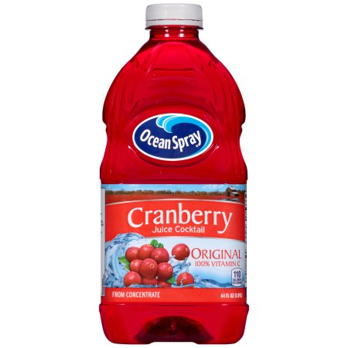Throughout the campaign, we will track, analyze, and report key product indicators each month to evaluate the campaign’s performance. By doing this, we will understand potential growth opportunities better. We will base our evaluation off of brand awareness, effectiveness, and sales.

Brand awareness will be measured by tracking the click-through rates and impressions on a spreadsheet, as well as conducting multiple national questionnaires when the campaign is complete. This is to get a good idea at the consumers’ recognitions of Ocean Spray.

To measure effectiveness, we will track all Ocean Spray social media platforms to view the consumers’ public opinions on the juice. Using this, we will track changes in any social growth when the campaign has ended.

Lastly, we will keep track of all units sold monthly throughout the campaign. This will be beneficial to evaluate the total success of the campaign.



**Appendix**

**Tables and Charts**

In Tables 1 and 2 below, any decent (yellow) or very promising (green) index calculations for the millennial-heavy markets in the U.S. that correspond with the top juice drink markets have been highlighted. Using this information, the target geography markets for the Ocean Spray campaigns can be calculated (Table 3) and identified as the following:

1. Riverside-San Bernardino-Ontario, CA Metro Area
2. Jacksonville, FL
3. Miami-Fort Lauderdale-West Palm Beach, FL Metro Area
4. Tampa-St. Petersburg-Clearwater, FL Metro Area
5. Boston-Cambridge-Newton, MA-NH Metro Area
6. Baltimore-Columbia-Towson, MD Metro Area
7. Las Vegas-Henderson-Paradise, NV
8. Buffalo-Cheektowaga-Niagara Falls, NY Metro Area
9. Charlotte-Concord-Gastonia, NC-SC Metro Area
10. Raleigh, NC
11. Philadelphia-Camden-Wilmington, PA-NJ-DE-MD Metro Area
12. Pittsburgh, PA
13. Providence-Warwick, RI-MA Metro Area
14. Washington-Arlington-Alexandria, DC-VA-MD-WV Metro Area
15. Richmond, VA
16. Virginia Beach-Norfolk-Newport, VA-NC Metro Area
17. Seattle-Tacoma-Bellvue, WA Metro Area

***Table 2: 2017 Indices of the Top 25 Juice Drink Markets in the US*** (US Food ScanTrack Markets, 2017)

|  |  |  |  |
| --- | --- | --- | --- |
| **City** | **Index** | **City** | **Index** |
| Miami, FL | 145.4 | Phoenix, AZ | 115.3 |
| Boston, MS | 141.0 | Las Vegas, NV | 114.4 |
| Greater Maine, ME | 137.1 | Los Angeles, CA | 113.1 |
| Buffalo/Rochester,  NY | 131.2 | Grand Rapids, MI | 113.3 |
| Baltimore, MD | 125.6 | Syracuse, NY | 112.1 |
| Seattle, WA | 125.6 | Jacksonville, FL | 111.9 |
| Hartford, NH | 123.5 | Denver, CO | 109.4 |
| Albany, NY | 123.4 | Richmond, VA | 108.4 |
| Detroit, MI | 121.9 | Atlanta, GA | 107.2 |
| Tampa, FL | 118.4 | San Diego, CA | 104.8 |
| Orlando, FL | 117.9 | DC | 104.1 |
| Portland, OR | 117.0 | Eastern Carolinas, NC | 103.1 |
| Philadelphia, PA | 116.0 |  |  |

**Appendix (cont.)**

**Tables and Charts (cont.)**

***Table 3: 2017 Indices of 25-34 Year-Olds in the Top 25 Millennial-Heavy Markets in the US*** (Data USA, 2017)

|  |  |  |  |
| --- | --- | --- | --- |
| **City** | **Index** | **City** | **Index** |
| Virginia Beach-Norfolk- Newport, VA-NC Metro Area | 113 | Richmond, VA | 146 |
| Riverside-San Bernardino- Ontario, CA Metro Area | 104 | Baltimore-Columbia-Towson, MD Metro Area | 106 |
| Memphis, TN-MS-AR Metro Area | 100 | Boston-Cambridge-Newton, MA-NH Metro Area | 108 |
| New Orleans-Metairie, LA Metro Area | 112 | Miami-Fort Lauderdale-West Palm Beach, FL Metro Area | 98 |
| Austin-Round Rock, TX Metro Area | 126 | Philadelphia-Camden-Wilmington, PA-NJ-DE-MD Metro Area | 102 |
| Pittsburgh, PA | 151 | Buffalo-Cheektowaga-Niagara Falls, NY Metro Area | 98 |
| San Antonio-New Braunfels, TX | 108 | Salt Lake City, UT | 157 |
| Seattle-Tacoma-Bellevue, WA Metro Area | 118 | Jacksonville, FL | 118 |
| Raleigh, NC | 132 | Houston-The Woodlands-Sugar Land, TX Metro Area | 110 |

|  |  |  |  |
| --- | --- | --- | --- |
| **City (cont.)** | **Index** | **City (cont.)** | **Index** |
| Charlotte-Concord-Gastonia, NC-SC Metro Area | 99 | Washington-Arlington-Alexandria, DC-VA-MD-WV Metro Area | 111 |
| Providence-Warwick, RI-MA Metro Area | 96 | Las Vegas-Henderson- Paradise, NV Metro Area | 108 |
| Tampa-St. Petersburg- Clearwater, FL Metro Area | 94 | New York-Newark-Jersey City, NY-NJ-PA Metro Area | 107 |
| Columbus, OH | 150 |  |  |

***Figure 1: US Food ScanTrack Markets Geographic Index Heat Map in 2017*** (US Food ScanTrack Markets, 2017)

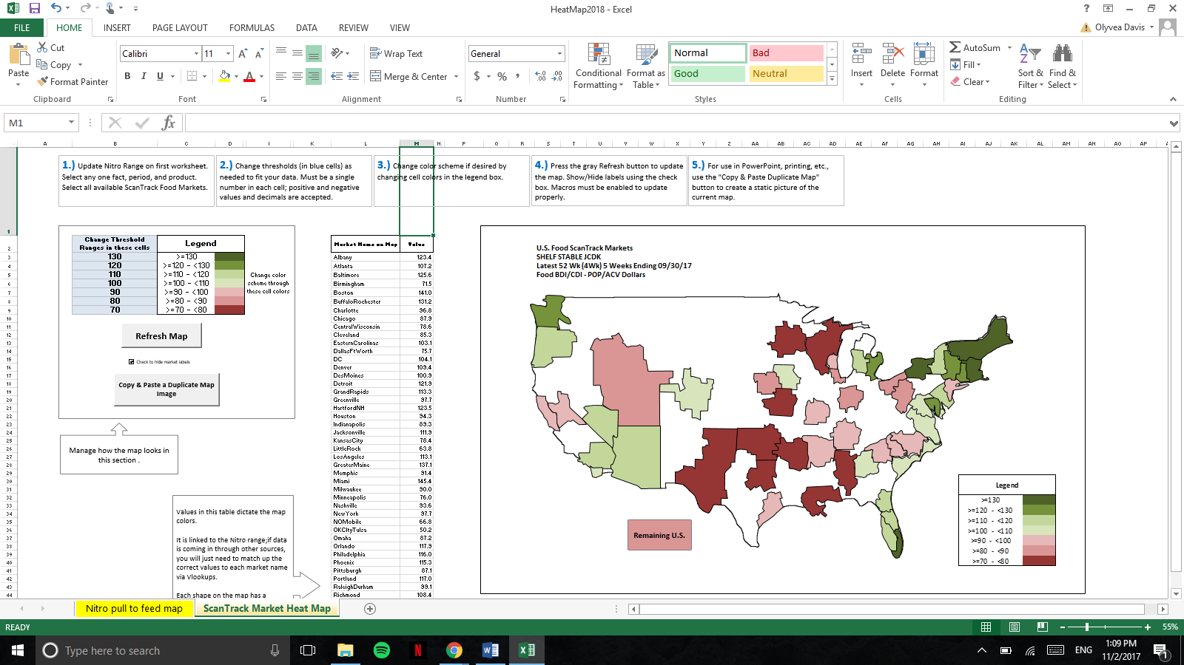

**Appendix (cont.)**

**Tables and Charts (cont.)**

Using the locations where millennials have been moving, the population of 25-34 year olds in each area can then be determined using Data USA. Data USA provided two numbers for the population in each city: the population of local-born 25-34 year-olds and the population of 25-34 year-olds that moved to the city. Using the sum of these two numbers, the percentage of 25-34 year-olds could be determined by dividing the sum by the total 25-34 year-olds in the city. This information, along with the total number of 25-34 year olds in the United States (US) can be used to find the index number for each popular millennial market using the following formula and total population calculation:

Index Number =

US Population Target Market (%) = (Total 25-34 year-olds in US)/(Total US Population) =>

(7730000+36200000)/321000000 = 13.69% (Data USA, 2017)

***Table 4: Calculations of Indices of 25-34 Year-Olds in the Top 25 Millennial-Heavy Markets in the US*** (Data USA, 2017)

|  |  |  |  |
| --- | --- | --- | --- |
| **City** | **Index** | **City** | **Index** |
| Virginia Beach-Norfolk- Newport, VA-NC  (18686+247954)/1720000 = 15.5 | 113 | Richmond, VA  (4580+38217)/213735 = 20.02 | 146 |
| Riverside-San Bernardino- Ontario, CA  (133260+503783)/4490000 = 14.19 | 104 | Baltimore-Columbia-Towson, MD  (59556+347840)/2800000 = 14.55 | 106 |
| Memphis, TN-MS-AR  (17184+167081)/1340000 = 13.75 | 100 | Boston-Cambridge-Newton, MA-NH  (172351+530543)/4770000 = 14.74 | 108 |
| New Orleans-Metairie, LA  (17594+174958)/1260000 =15.28 | 112 | Miami-Fort Lauderdale-West Palm Beach, FL  (335442+473241)/6010000 = 13.46 | 98 |
| Austin-Round Rock, TX  (76432+268270)/2000000 = 17.24 | 126 | Philadelphia-Camden- Wilmington, PA-NJ-DE-MD  (127230+721016)/6070000 = 13.97 | 102 |
| Pittsburgh, PA  (9220+53535)/304385 = 20.62 | 151 | Buffalo-Cheektowaga-Niagara Falls, NY  (13815+138502)/1140000 = 13.36 | 98 |
| San Antonio-New Braunfels, TX  (44773+307777)/2380000 = 14.81 | 108 | Salt Lake City, UT  (8385+32493)/190679 = 21.44 | 157 |
| Seattle-Tacoma-Bellevue, WA  (137176+467006)/3730000 = 16.2 | 118 | Jacksonville, FL  (17693+122466)/868031 = 16.15 | 118 |
| Raleigh, NC  (14196+67474)/451949 = 18.07 | 132 | Houston-The Woodlands-Sugar Land, TX  (309134+694238)/6660000 = 15.07 | 110 |
| Charlotte-Concord-Gastonia, NC-SC Metro Area  (51454+277024)/2430000 = 13.52 | 99 | Washington-Arlington-Alexandria, DC-VA-MD-WV  (256375+672678)/6100000 = 15.23 | 111 |
| Providence-Warwick, RI-MA  (33231+178870)/1610000 = 13.17 | 96 | Las Vegas-Henderson- Paradise, NV  (82095+230481)/2110000 = 14.81 | 108 |
| Tampa-St. Petersburg- Clearwater, FL  (64095+319360)/2980000 = 12.87 | 94 | New York-Newark-New Jersey, NY-NJ-PA  (2950000)/20200000 = 14.6 | 107 |
| Columbus, OH  (29468+144603)/849067 = 20.5 | 150 |  |  |

**Appendix (cont.)**

**Tables and Charts (cont.)**

|  |  |  |
| --- | --- | --- |
| **Ostrow Model** | | |
| **Part I: Marketing Factors That Affect Frequency** | | |
| Established brand? | Yes, according to Ocean Spray, they were established in 1930 (n.d). | (-) 0.2 |
| High market share? | No, according to Bryant, market share is 6.4% (2017). | (+) 0.1 |
| Dominant brand? | Yes, according to Bryant, Ocean Spray is considered one of the lower leading juice brands (2017). | (-) 0.1 |
| High brand loyalty? | Yes, according to InfoScout, based on a survey of panelist who purchase Ocean Spray products, only 27% said they would purchase a different brand if an Ocean Spray product was out of stock. The other 73% responded with answers that ensured loyalty to Ocean Spray products (n.d.). | (-) 0.1 |
| Long purchase cycle? | No, according to Bryant, in the past three months 85% of consumers have purchased juice. (2017) | (+) 0.1 |
| Product used occasionally? | No, according to Bryant, 77% of any juice is consumed at least "weekly or a few times a day," 42% of those consume more than once a day. (2017) | (+) 0.1 |
| Need to beat competition? | Yes, according to Ocean Spray, the goal is to become more prominent (2017). | (+) 0.2 |
| **Part II: Copy Factors That Affect Frequency** | | |
| Simple copy? | Yes, message will be very simple. | (-) 0.2 |
| Copy more unique than competitor? | Yes, better every campaign. | (-) 0.2 |

|  |  |  |
| --- | --- | --- |
| **Part II: Copy Factors That Affect Frequency (cont.)** | | |
| Continuing campaign? | No, this is a brand new creative concept. | (+) 0.2 |
| Product sell copy? | Yes, a combination of image and product sell. | (+) 0.1 |
| Single kind of message? | Yes, medium continuity creative strategy. | (-) 0.1 |
| To avoid wear out: new messages? | Yes, copy strategy fresh, new. | (-) 0.1 |
| Larger ad units? | No, smaller ad units, to stay within budget | (+) 0.1 |
| **Part III: Media Factors That Affect Frequency** | | |
| Lower ad clutter? | No, media selected have high clutter. | (+) 0.2 |
| Compatible editorial? | Yes, lots of opportunity for related editorial. | (-) 0.1 |
| Attentiveness high? | No, low involvement in product category. | (+) 0.2 |
| Continuous advertising? | No, pulsing advertising will be used. | (+) 0.1 |
| Few media used? | Yes, mostly digital | (-) 0.1 |
| Opportunities for media repetition? | Yes, emphasizing frequency | (-) 0.1 |
| **Estimated Frequency Results:** | | **3.2** |



**Appendix (cont.)**

**Tables and Charts (cont.)**

**Appendix (cont.)**



**Tables and Charts (cont.)**



**Appendix (cont.)**

**Tables and Charts (cont.)**

***Figure 2: Statista Seasonal Purchase of Fruit Juice Survey*** (Statista, 2017)

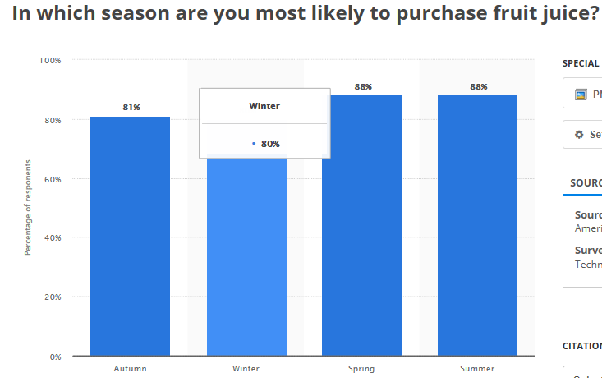

**References**

Arnold Street Media. (May 2016). *It’s all about the Visuals: How to*

*Target Millennials with Content.* Arnold Street Media. Retrieved

November 30, 2017 from <http://arnoldstreet.com/visuals-target-millennials-content/>

Boland, L. B. (November 2015). *Massive share of US millennials*

*stream video on Netflix and YouTube.* Business Insider. Retrieved

December 1, 2017 from <https://www.businessinsider.com/massive-share-of-us-millennials-stream-video-on-netfli>[x-and-youtube-2015-11](https://www.businessinsider.com/massive-share-of-us-millennials-stream-video-on-netflix-and-youtube-2015-11)

Bryant, C. (May 2017). *Juice and Juice Drinks - US - May 2017.*

Mintel. Retrieved December 12, 2017 from <http://academic.mintel.com/display/833309/>

Central Authentication Service. (n.d.). Mintel. Retrieved December 1,

2017 from <http://academic.mintel.com.libproxy.library.wmich.edu/display/833309/>

Conservation International. (2017). *About Us - Conservation*

*International.* Conservation International. Retrieved November 30,

2017 from <https://www.conservation.org/about/Pages/default.aspx>

Data USA. (2017). *Data USA.* Data USA. Retrieved November 17,

2017 from <https://datausa.io/>

Digital Signage Today. (July 2015). *Nielson study highlights efficacy*

*of digital billboards | Digital Signage Today.* Digital Signage

Today. Retrieved December 11, 2017 from

<https://www.digitalsignagetoday.com/news/nielsen-study-highlights-efficacy-of-digital-bi>[llboards/](https://www.digitalsignagetoday.com/news/nielsen-study-highlights-efficacy-of-digital-billboards/)

Johnson, D. (June 2017). *The 25 Cities Where Millennials Are Moving.*

TIME. Retrieved November 14, 2017 from

<http://time.com/4797956/cities-millennials-moving/>

**Appendix (cont.)**

**References (cont.)**

Gibbs, A. & Hungerford, N. (November 2016). *Millennials willing to pay more for*

*sustainable, better quality goods: Nestlé Chairman.* CNBC. Retrieved

November 20, 2017 from <https://www.cnbc.com/2016/11/04/millennials-willing-to-pay-more-for-sustainable-better>[-quality-goods-nestle-chairman.html](https://www.cnbc.com/2016/11/04/millennials-willing-to-pay-more-for-sustainable-better-quality-goods-nestle-chairman.html)

Ghosh, Rupa. (April 2016). *Millennial Travelers - US - April 2016*. Mintel.

Retrieved November 21, 2017 from <http://academic.mintel.com.libproxy.library.wmich.edu/display/769059/>

Google, Inc. (2017). *Google Images*. Retrieved December 11, 2017 from

<https://www.google.com/imghp?hl=en&tab=wi>

Greenwood, S., Perrin, A., & Duggan, M. (November 2016). *Social Mention Update*

*2016*. Pew Internet. Retrieved December 5, 2017 from

<http://www.pewinternet.org/2016/11/11/social-media-update-2016>

O’Donnell, Fiona. (November 2017). *Lifestyles of Multicultural Young Adults - US –*

*November 2017.* Mintel. Retrieved November 21, 2017 from

<http://academic.mintel.com.libproxy.library.wmich.edu/display/796259/>

IncomeDiary. (2017). *How To Make Money Online.* IncomeDiary. Retrieved

November 30, 2017 from <https://incomediary.com>

InfoScout. (2017). *Survey Ocean Spray Consumers in Our Research Panel.*

InfoScout. Retrieved December 12, 2017 from <https://www.infoscout.co/brand/ocean_spray/survey>

Ismail, Maimunah. (n.d.) *Cultural Values and Career Goals of the Millennial*

*Generation: An Integrated Conceptual Framework.* Retrieved November 21,

2017 from <http://www.jimsjournal.org/4%20Maimunah%20Ismail.pdf>

Lewis, M. & Friedlander, A. (September 2017). *How Millennial Shopping Habits*

*Relate to US Grocery Shopper Trends 2017*. FMI. Retrieved December 6, 2017 from <https://www.fmi.org/blog/view/fmi-blog/2017/09/15/how-millennial-shopping-habits-relate-to-u.s.-grocery-shopper-trends-2017>

Macke, Dana. (August 2017). *Millennial Dads - US - August 2017.* Mintel. Retrieved

November 21, 2017 from

<http://academic.mintel.com.libproxy.library.wmich.edu/display/793997/>

Macke, Dana. (September 2017). *Marketing to Moms - US - September 2017.* Mintel.

Retrieved November 21, 2017 from

<http://academic.mintel.com.libproxy.library.wmich.edu/display/794055/>

Mansfield, M. (January 2017). *Display Advertising Statistics for Different Types of*

*Digital Ads.* Small Business Trends. Retrieved December 1, 2017 from

<https://smallbiztrends.com/2017/01/display-advertising-statistics.html>

Mintel Group LTD. (May 2017). *Company and Brand Sales of 100% Juice, Juice*

*Drinks, and Smoothies.* Mintel Group LTD. Retrieved November 14, 2017 from

<https://academic.mintel.com/display/833309>

Mitskavets, Ina. (October 2013). *Lifestyles of Dads - UK - October 2013.* Mintel.

Retrieved November 21, 2017 from

[http://academic.mintel.com.libproxy.library.wmich.edu/display/638291](http://academic.mintel.com.libproxy.library.wmich.edu/display/638291/)

Ocean Spray Cranberries, Inc. (2016). *Cranberries in the Classroom.* Ocean Spray

Cranberries, Inc. Retrieved November 30, 2017 from

<http://www.oceanspray.coop/CorporateSite/media/Cranberries-In-The-Classroom/FactSh>[eetsAndPresentations/Ocean-Spray-History.pdf](http://www.oceanspray.coop/CorporateSite/media/Cranberries-In-The-Classroom/FactSheetsAndPresentations/Ocean-Spray-History.pdf)

Ocean Spray Cranberries, Inc. (2017). *The Cooperative’s History Since 1930 |*

*Ocean Spray.* Ocean Spray Cranberries, Inc. Retrieved December 12, 2017

from <http://www.oceanspray.com/Who-We-Are/Heritage/Our-History.aspx>

Pew Research Center. (January 2017). *Demographics of Mobile Device Ownership*

*and Adoption in the United States | Pew Research Center.* Pew Research Center.

Retrieved December 1, 2017 from <http://www.pewinternet.org/fact-sheet/mobile/>

**Appendix (cont.)**

**References (cont.)**

REDBOOKS. (2016). *REDBOOKS - The Leading Agency and Advertising*

*Database.* REDBOOKS. Retrieved December 12, 2017 from <https://www.redbooks.com/>

REDBOOKS Academic Edition. (n.d.). Retrieved November 21, 2017 from

<https://www.redbooks.com/dotCMS/subscriberDashboard>

REDBOOKS Agency and Advertising Database. (n.d.) *Coca-Cola.* REDBOOKS

Agency and Advertising Database. Retrieved November 17, 2017 from

<https://www.redbooks.com/dotCMS/brandProfile?tradeNameId=262825&dispatch=brand>[Profile#](https://www.redbooks.com/dotCMS/brandProfile?tradeNameId=262825&dispatch=brandProfile)

REDBOOKS Agency and Advertising Database. (n.d.) *Kraft.* REDBOOKS Agency

and Advertising Database. Retrieved November 17, 2017 from

<https://www.redbooks.com/dotCMS/brandProfile?tradeNameId=315344&dispatch=brand>[Profile](https://www.redbooks.com/dotCMS/brandProfile?tradeNameId=315344&dispatch=brandProfile)

Roberts, Tonya. (May 2014). *Black Consumers and Social Media - US - May 2014.*

Mintel. Retrieved November 21, 2017 from

<http://academic.mintel.com.libproxy.library.wmich.edu/display/681214/>

Salpini, Cara. (June 2017). *Millennials seek emotional connections before*

*purchasing.* Retail Dive. Retrieved November 30, 2017 from

<https://www.retaildive.com/news/millennials-seek-emotional-connections-before-purchas>[ing/445545/](https://www.retaildive.com/news/millennials-seek-emotional-connections-before-purchasing/445545/)

Schawbel, Dan. (January 2015). *10 New Findings About The Millennial Consumer.*

Forbes. Retrieved December 1, 2017 from

<https://www.forbes.com/sites/danschawbel/2015/01/20/10-new-findings-about-the-millen>[nialconsumer/2/#43e81a4e1474](https://www.forbes.com/sites/danschawbel/2015/01/20/10-new-findings-about-the-millennialconsumer/2/#43e81a4e1474)

Statista. (2017). *Facebook users worldwide 2017.* Statista. Retrieved December 1,

2017 from <https://www.statista.com/statistics/264810/number-of-monthly-active-facebook-users-wo>[rldwide/](https://www.statista.com/statistics/264810/number-of-monthly-active-facebook-users-worldwide/)

Statista. (2017). *Seasonal preferences in fruit juice purchases 2012 | Survey.* Statista.

Retrieved December 12, 2017, from <https://www-statista-com.libproxy.library.wmich.edu/statistics/235603/us-fruit-juice-seas>[onal-purchases/](https://www-statista-com.libproxy.library.wmich.edu/statistics/235603/us-fruit-juice-seasonal-purchases/)

Statista. (2017). *Time Millennials spend with media in the U.S. 2016 | Statistic*.

Statista. Retrieved December 12, 2017, from

<https://www.statista.com/statistics/281601/media-time-millennials/>

US Climate Data (2017). *Climate - United States - Monthly averages.* US Climate

Data. Retrieved December 12, 2017, from <http://www.usclimatedata.com/>

US Food ScanTrack Markets. (2017). *Heat Map 2018.* US Food ScanTrack Markets.

Retrieved November 2, 2017.

University Reporter. (n.d.) Retrieved December 1, 2017 from

<https://www.gfkmrismartsystem.com/UniversityReporter/Report.aspx>